Completion Date: August 2014
Client: The Maryland Business Roundtable (MBRT)
No.Inc partnered with the Maryland Business Roundtable to redesign its STEMnet website that connects teachers in the classroom with professionals in the fields of science, technology, engineering, and mathematics. Serving as a meeting place for educators and professionals, STEMnet users schedule experienced professionals into classes with students so they can see firsthand the connection between classroom subjects and real world STEM careers. Redesigning the site and workflows provided easier access to resources, reports, and professional connections. On the administrative side, we created several reporting tools that facilitate monitoring activities and status of speakers in classrooms.

The Challenges
- Support multiple program types and workflows within the same onboarding and reporting framework
- Optimize an older Drupal theme
- Add and change features of an active system

Our Approach
- Establish clear goals
- Focus on key interfaces for improvements
- Optimize code and UI wherever possible

The Results
- Improved speed and performance
- Better user tracking and reporting
- Site enhancements

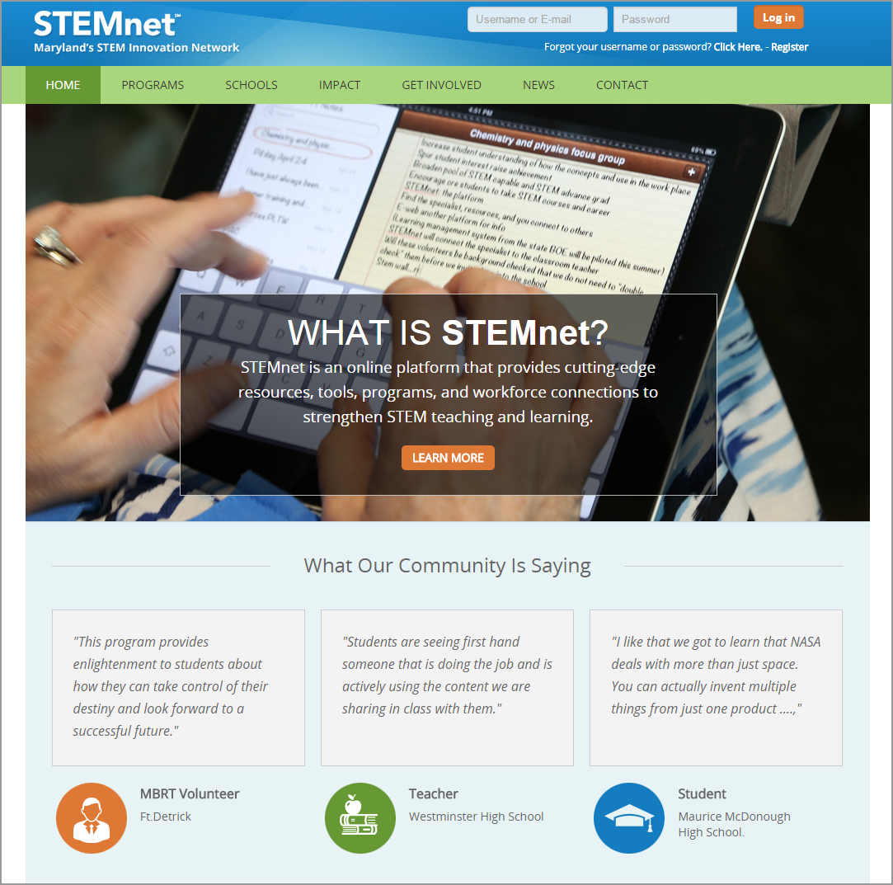 | 