Completion Date: March 2016
Scale: Designed to accommodate 1,000,000 students and 20,000 users
Partner: Johns Hopkins University, The Center for Technology in Education
No.Inc partnered with Johns Hopkins University’s Center for Technology in Education to plan, design, and develop the technology to support the statewide Early Learning Assessment in Maryland and Ohio. The formative assessment will be administered to about 1,000,000 early learners across both states and will be used daily by over 20,000 teachers and administrators. Teachers plan, score, and collect artifacts on any combination of up to 50 items in a special activity workspace built into the solution.

The Challenges
- Collaborate with content experts, stakeholders, and decision makers
- Accommodate many concurrent users; 120,000 users and 1,000,000 students
- Meet special education requirements regarding Child Outcomes Summary
- Decentralize data management to respect school district autonomy

Our Approach
- Develop a cross-platform mobile app
- Integrate with existing classroom process and flow using activity planner approach
- Speed data entry using recognizable browser based spreadsheet style data entry
- Build on platform developed for Kindergarten Readiness Assessment
- Gather requirements from both states and create one system
- Create scalable system using the Amazon Cloud
- Provide sophisticated data management tools for loading and managing data by district

The Results
- Targeted implementation in both states for 2016
- An extremely useful and widely used tool for teachers that is useful in the classroom as well as at local and state agency levels
Teacher Facing Mobile User Interface
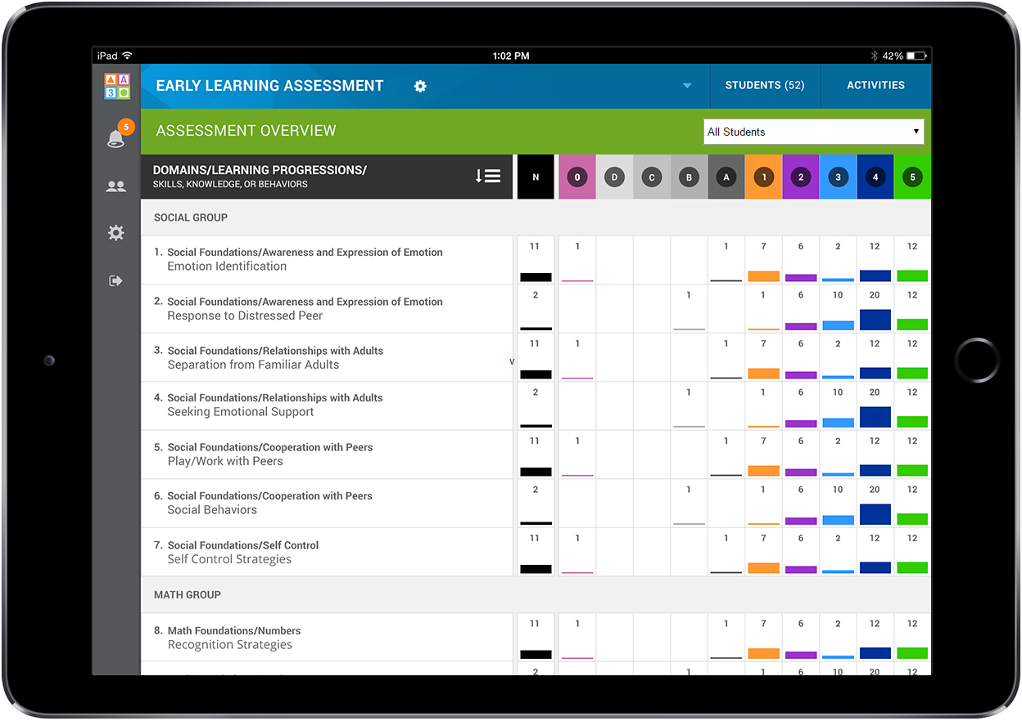
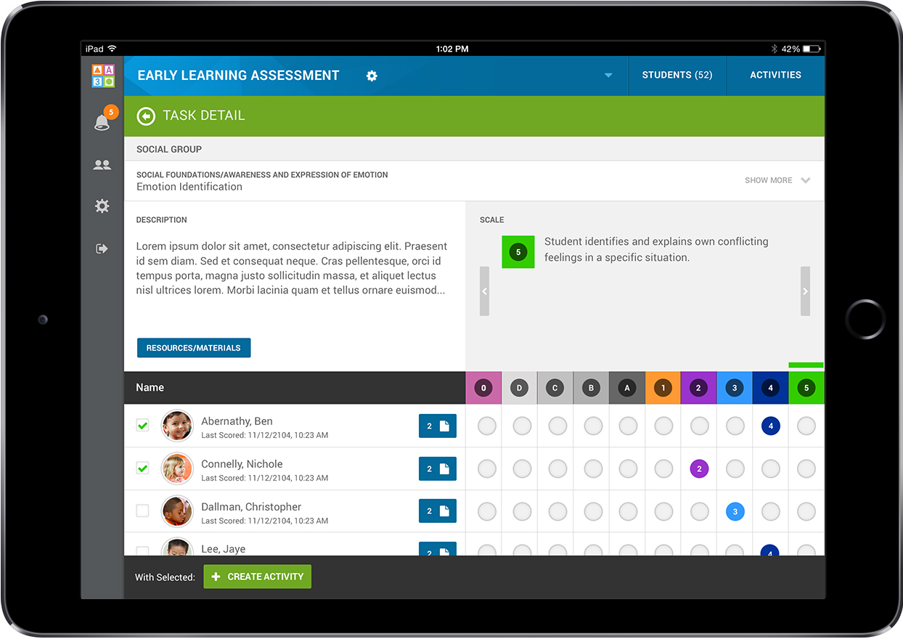 | 