Scale: 100,000 Students and 10,000 users
Partner: Johns Hopkins University, The Center for Technology in Education
No.Inc partnered with Johns Hopkins University’s Center for Technology in Education to create the user interface design of the Maryland IEP system. The system is used to manage, plan, and document the Individualized Education Program for special education students. Multiple user roles (case managers, administrators, specialists, teachers, and parents) utilize the system in classroom environments, administrative planning sessions, and during IEP meetings.

The Challenges
- Support several user groups with varying goals and tasks
- Make it easy enough to minimize significant classroom training
- Accommodate advanced and beginner users equally

Our Approach
- Audit usability of existing system
- Use case and task flow development
- Wireframe prototyping and design
- Develop high fidelity prototype and design
- Produce template
- Build in user flexibility to accommodate experienced and new users

The Results
- Reduced errors and improved troubleshooting due to accurate mapping of workplace terminology to interface elements
- Sleek, modern, and thoroughly professional UI design

Case Management
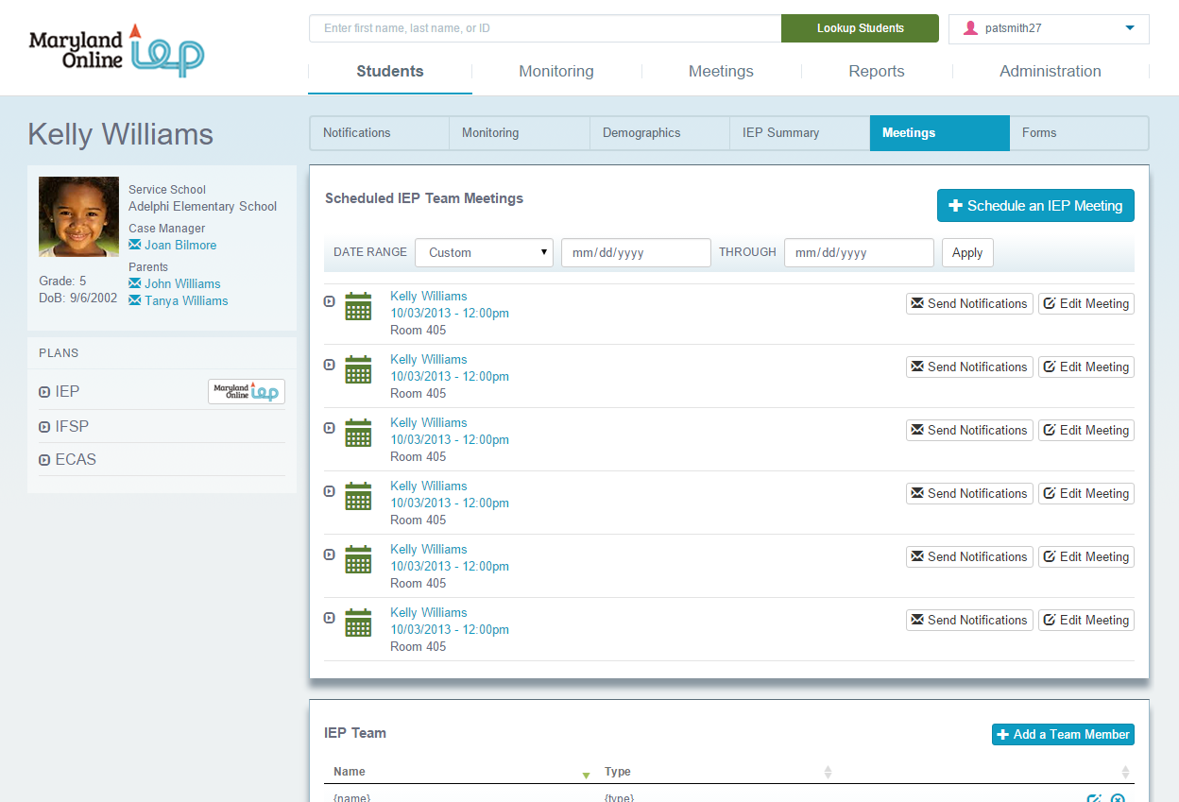
IEP Goals  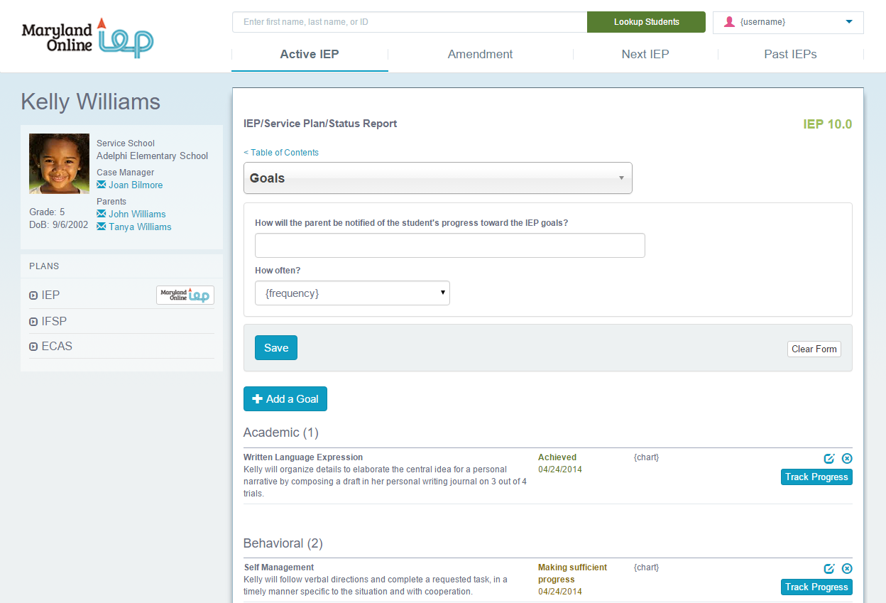 | Performance Summary  