Completion Date: December 2013
Client: The Rubin Institute for Advanced Orthopedics at Sinai Hospital
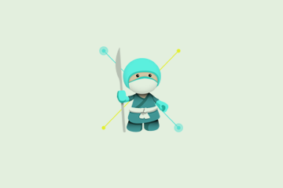
No.Inc partnered with Sinai Hospital and the Rubin Institute of Advanced Orthopedics to create a mobile app to train orthopedic surgeons on procedures for correcting bone deformity.

The old teaching method still uses paper cutouts, scotch tape, and pencils. Expensive desktop-only versions are not viable for learning environments or planning when the user is away from a computer.

The app, Bone Ninja, comes with several lessons that can be used to train doctors. More lessons can be added and downloaded to the app. Users can capture x-rays and other images and import them into the app. After an image is imported, a calibration tool can be used on the x-ray to ensure that bone lengths are measured accurately. It also allows doctors to learn treatment strategies by measuring angles and simulating how to correct "crooked" bones on x-rays.

The Challenges
- Ensure accuracy
- Build in performance and usability

Our Approach
- Hold planning sessions with doctors and medical illustrators
- Build upon current traditional and digital planning methods

The Results
- Widely used by orthopedic surgeons around the world
- Application extended to such areas as clinical evaluation of clubfoot

iPad App  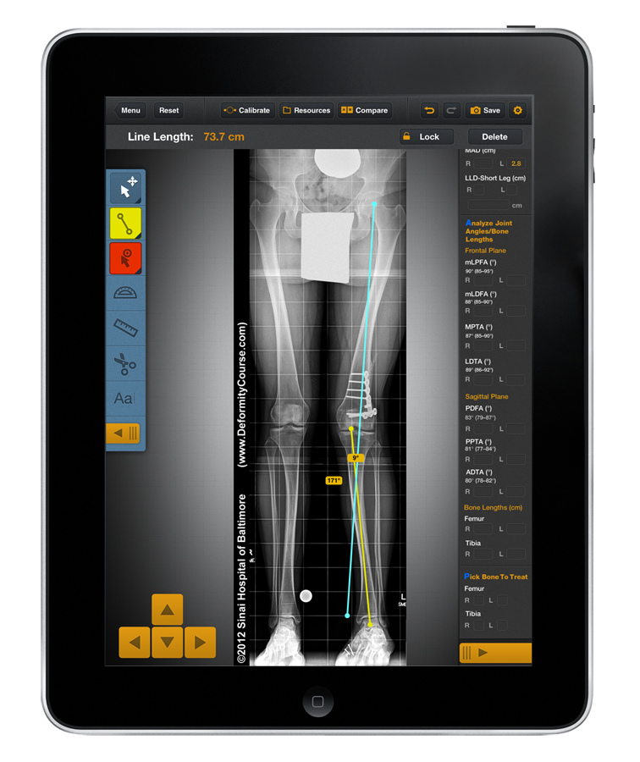 | 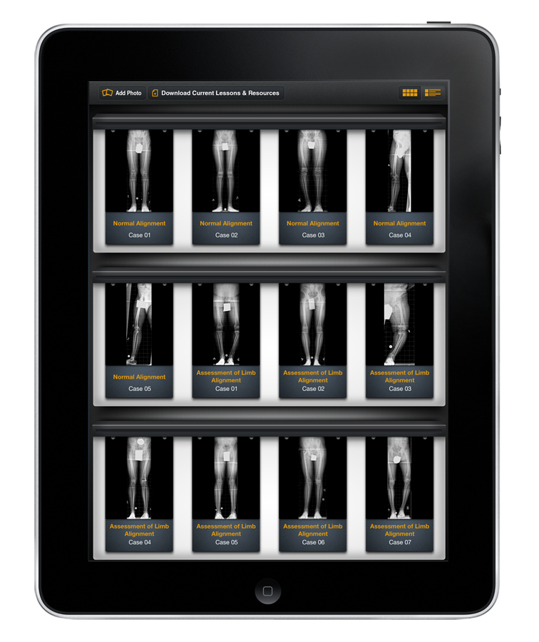

“NoInc was able to take a rough concept and develop a sophisticated application that has become THE standard for teaching orthopedic surgeons about deformity planning and correction. They are creative, professional and adjusted quickly to our vision as the Bone Ninja was undergoing development. They are always on call should we have any concerns. Since its inception, they have hosted our app's extensive online resources and it has worked flawlessly.”

Dr. John E. Herzenberg
Director, International Center of Limb Lengthening
Director, Pediatric Orthopedics, Sinai Hospital of Baltimore

