Client: Smithsonian Institution
No.Inc partnered with the Department of Paleobiology at the National Museum of Natural History to create an online resource that explains the concept of geological time and traces the physical history of the planet.

We realized that we needed to create content for several types of users. We created a video documentary presentation for those passive users seeking to be entertained. For the more curious, we created an interactive timeline that allows active users to push, pull and play within the content. We created a deep database of artifacts to appease the most discriminating user. Most important, we made it scientifically accurate and intellectually stimulating.

The Challenges
- Absorb an overwhelming amount of information
- Reach scientific consensus of key evidence and dates
- Create a usable interface that spans billions of years

Our Approach
- Interview specialists from numerous disciplines within geologic time
- Prototype and design key interactive components
- Build in flexibility to add interactive components and timeline content

The Results
- Dynamic and interactive experience for exploring the complex concept of geologic time

Interactive  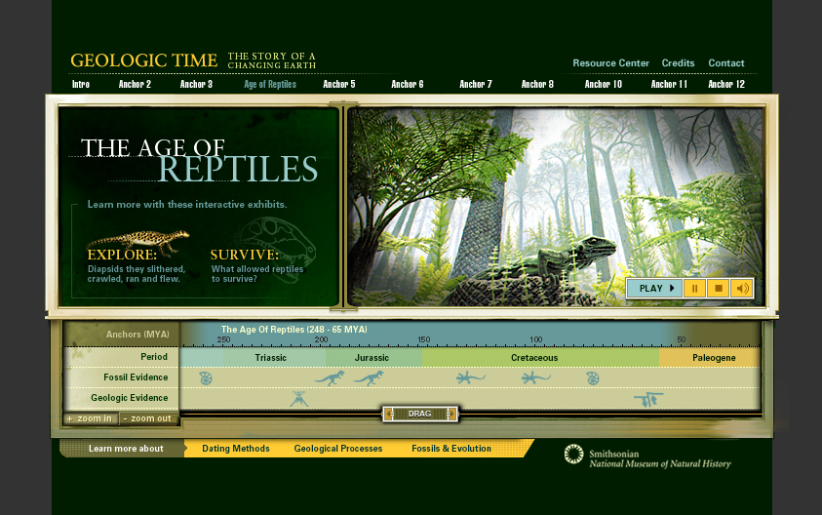 | 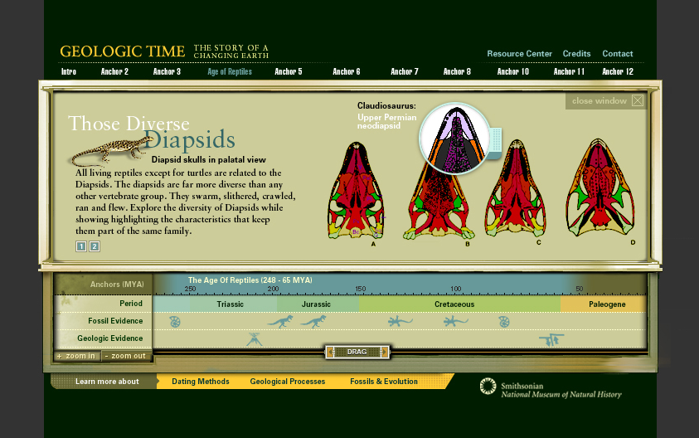
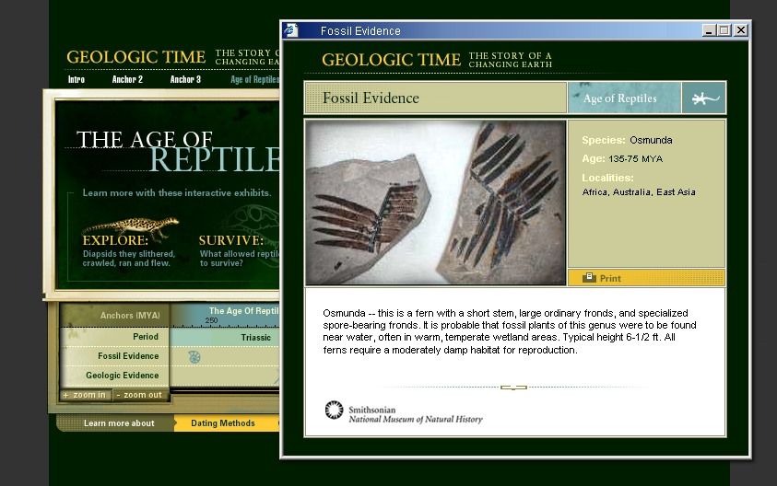 | 