Client: Owen Software
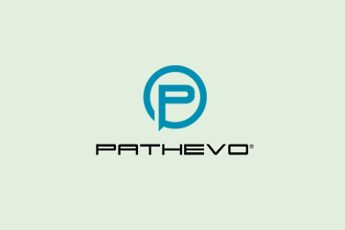
No.Inc partnered with Owen Software to plan and design a STEM career planning tool. Called Pathevo, the system helps students and advisors plan the steps along career paths for STEM subjects. The system starts off broad with an academic starting point and a desired outcome. It gradually gets more detailed about milestones such as class and credit requirements for a computer science degree.

Pathevo is designed to act as a guide for documenting achievements and milestones and presenting education options that help direct students along a path from high school through college.

The Challenges
- Manage infinite career path options
- Create a system that stays with a user through high school and beyond
- Create one system for students, faculty, parents, and advisors

Our Approach
- Conduct user interviews and create personas to guide interface decisions
- Design, prototype, and refine wireframes

The Results
- Successful product used in more than 30 schools

Plan Builder
