Completion Date: October 2011
Partner: Johns Hopkins University, The Center for Technology in Education
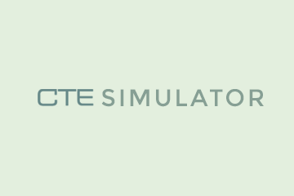
No.Inc partnered with Johns Hopkins University’s Center for Technology in Education to plan, design, and develop the CTE Classroom Scenario Simulator. Teachers are trained on a variety of topics using this interactive, online tool. The tool can be easily configured by an instructional designer using photos, graphics, icons, video, and audio. Interactive, panoramic scenes make up each simulation. A user can click on hotspots to navigate from scene to scene or to view details of a scene. Users are assessed in the tool by answering multiple choice questions about the scenario they are viewing.

The Challenges
- Provide an immersive user experience combining imagery, photos, panoramas, audio, and video created by educators
- Capture data and score users on questions answered about the simulation
- Measure inter-rater reliability among evaluators of classroom quality standards

Our Approach
- Modeled after early video games based on exploration
- Paired an assessment form with the interactive UI for capturing user input
- Browser based, universal access

The Results
- Professional development certifications issued for training programs

Simulation Scene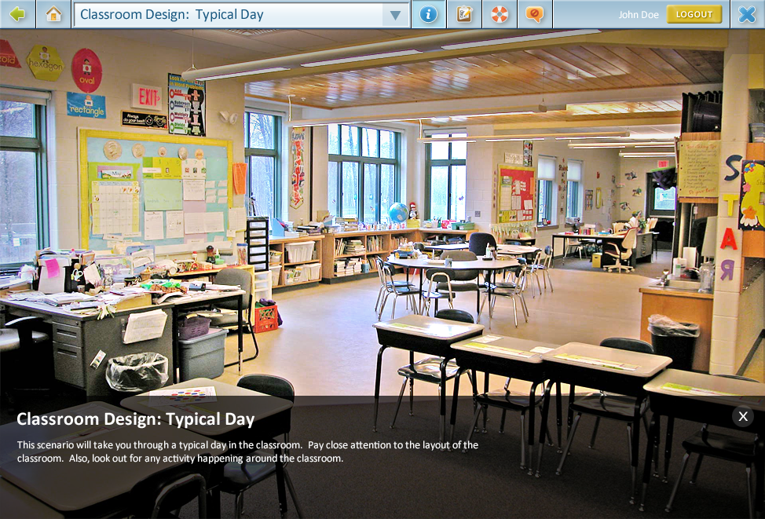 | 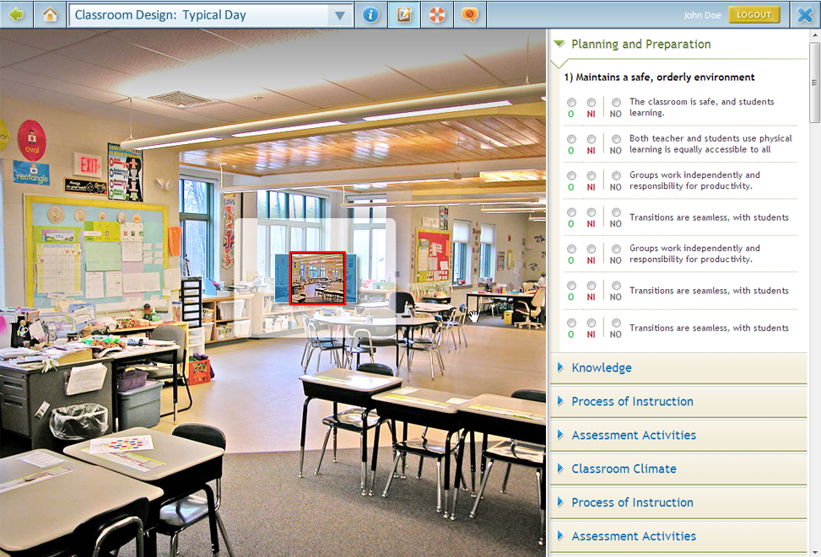
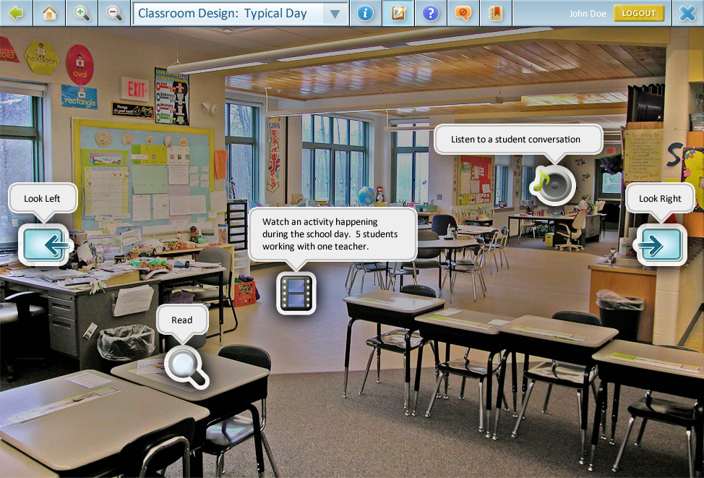 | 