Scale: 100,000 Students
Partner: Johns Hopkins University, The Center for Technology in Education
No.Inc partnered with Johns Hopkins University’s Center for Technology in Education to plan and design the Maryland Individual Family Service Plan (IFSP) system. The system is used to collect and manage all data related to a family’s IFSP. The user interface is designed to be simple and user friendly to accommodate the wide range of technical familiarity among the users. The tool proactively supports the user’s workflow by validating the entered data in real time and auditing the plan before it is committed.

The Challenges
- Replace a legacy system widely understood by staff but requiring thorough modernization

Our Approach
- Audit usability of existing system
- Use case and task flow development
- Prototype wireframes and design
- Prototype final version and template production

The Results
- Reduced errors and improved troubleshooting due to accurate mapping of workplace terminology to interface elements
- Sleek, modern, and thoroughly professional UI design

Development Outcomes Wizard
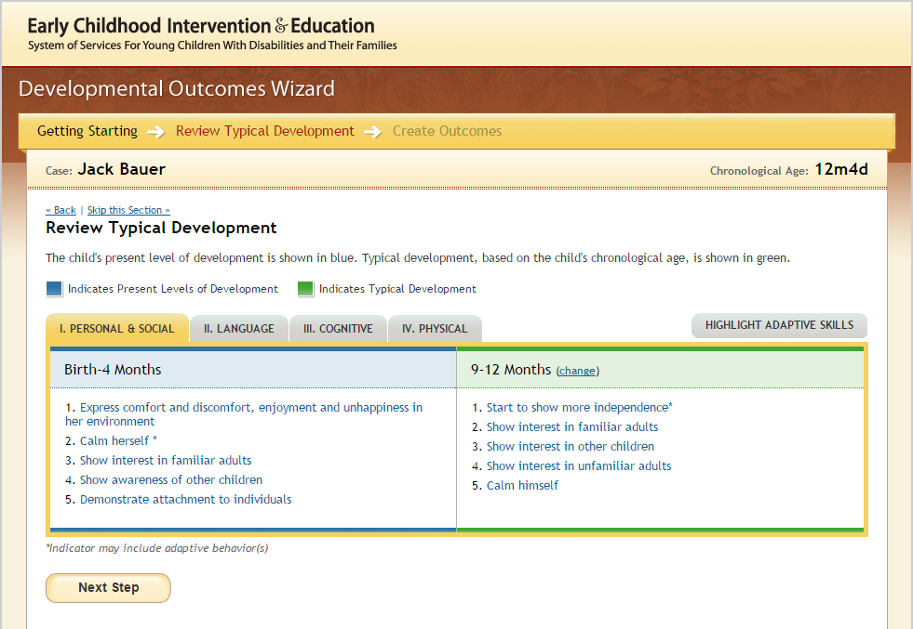
Present Levels of Development  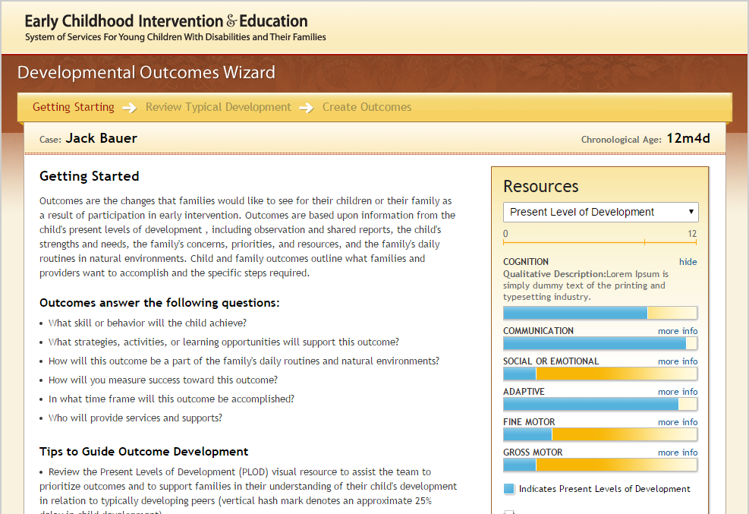 | Outcomes  