Completion Dates: July 2013 (1.0) / January 2017 (2.0)
Scale: 5,200 Programs
Partner: Johns Hopkins University, The Center for Technology in Education
No.Inc partnered with Johns Hopkins University’s Center for Technology in Education to plan, design, and develop the Quality Rating & Improvement System for Maryland (Maryland EXCELS). Serving more than 5,200 early childhood care providers across the state, the system is used daily by some 100 state quality assurance staff members and state QRIS administrators. The system helps participating early childhood care providers to continuously improve programs by working to meet improvement standards and best practices as defined by the state.

The Challenges
- Design a software system flexible enough to support a new process that would evolve
- Accommodate a business process developed in parallel with the software
- Accommodate a wide range of technical familiarity within audiences
- Integrated data from state licensing system

Our Approach
- Elicit requirements from various stakeholder groups
- Pilot a prototype and conduct field tests to collect user feedback
- Build a flexible system that adapts to evolving process
- Publish ratings through a new Maryland EXCELS website and mobile app

The Results
- Participation in the state QRIS program has increased over 5,000%
- Highest reviewer to program ratio in the country due to the efficiency of an online process

Responsive Mobile UI for Providers  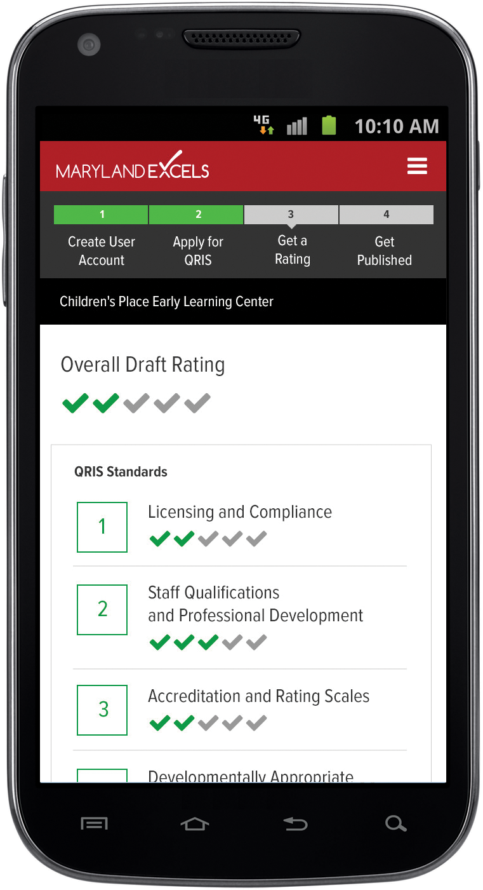 | Public Program Directory  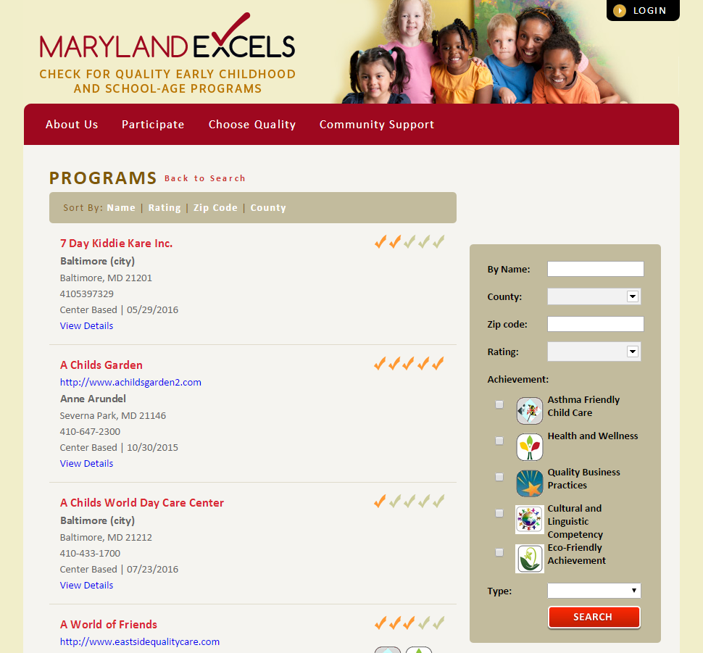

Administration System  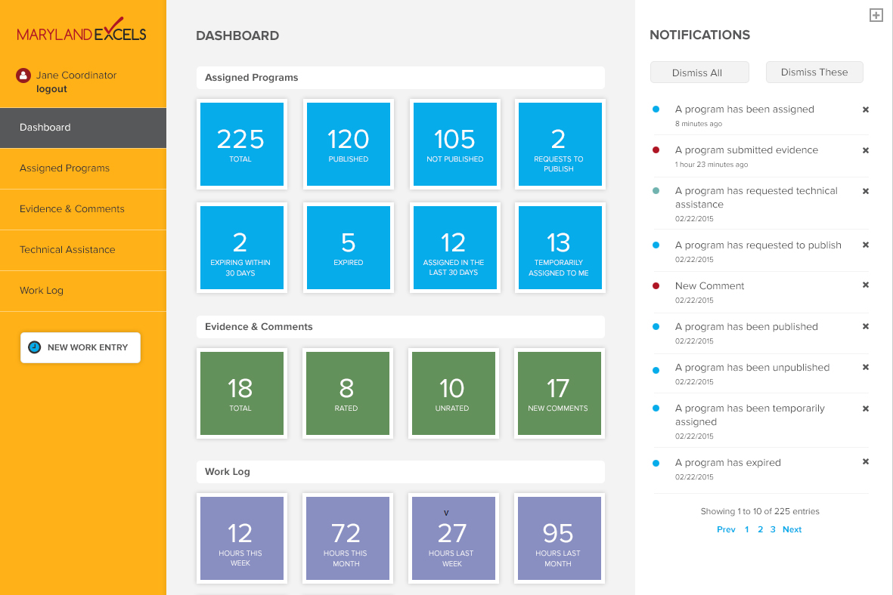 | 