Completion Date: July 2014
Scale: 100,000 students and 10,000 users
Partner: Johns Hopkins University, The Center for Technology in Education
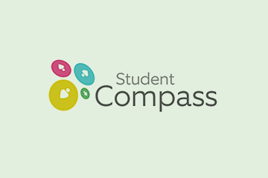
No.Inc partnered with Johns Hopkins University’s Center for Technology in Education to create the user interface design for a learner centric progress monitoring system that integrates with the state’s Individualized Education Program (IEP) system, Individual Family Service Plan (IFSP) system, Child Outcomes Summary (COS) system, and Special Services Information System (SSIS). The tool allows teachers, case managers, and service providers to view and track the student’s learning data from all of the integrated systems in one place. The most powerful feature of the tool is its ability to allow users to map student goals with curriculum, services, and interventions, and log progress on a timeline against a measurable target date and level of progress.

The Challenges
- Support several user groups with varying goals and tasks
- Make it easy enough to minimize significant classroom training
- Accommodate advanced and beginner users equally

Our Approach
- Use case and task flow development
- Wireframe prototyping and design
- Develop high fidelity prototype and design
- Build in user flexibility to accommodate experienced and new users

The Results
- Sleek, modern, and thoroughly professional UI design
- Wide adoption and plans to grow the tool

Responsive Mobile UI  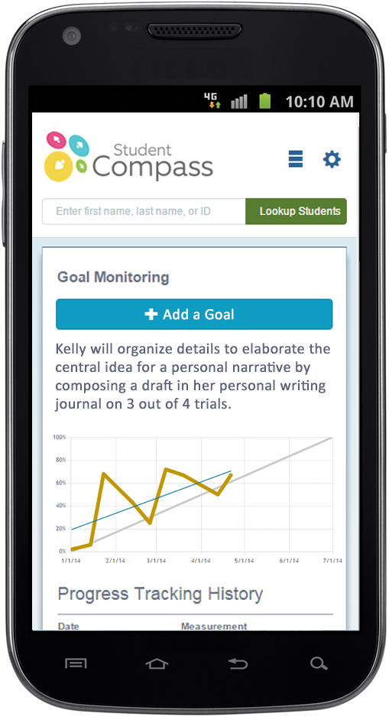 |  | Progress Monitoring: Goal Detail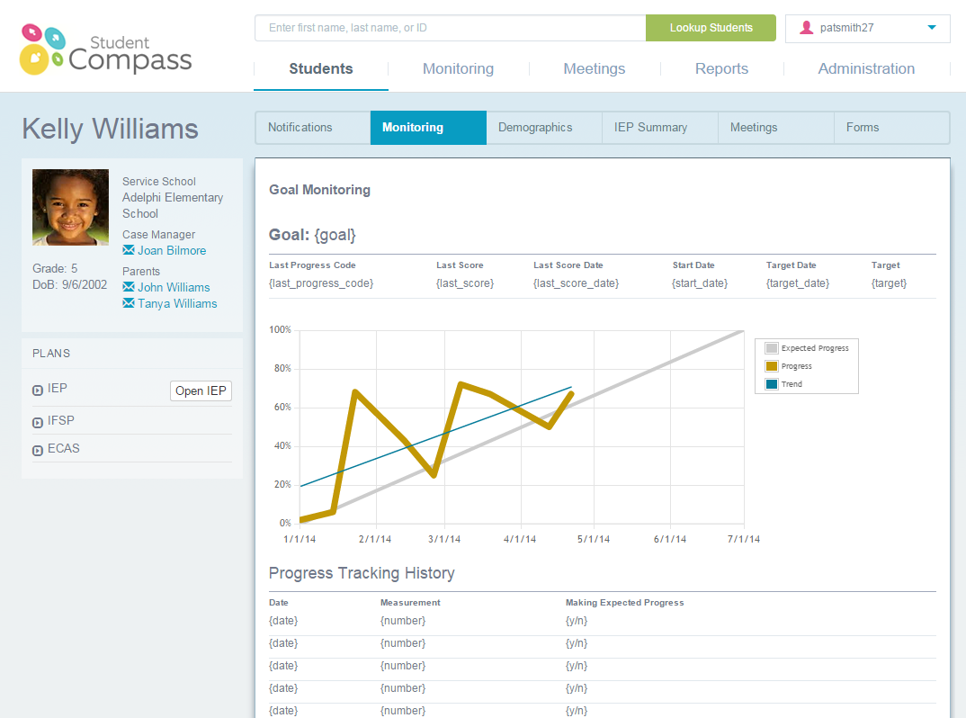

Goal Reporting  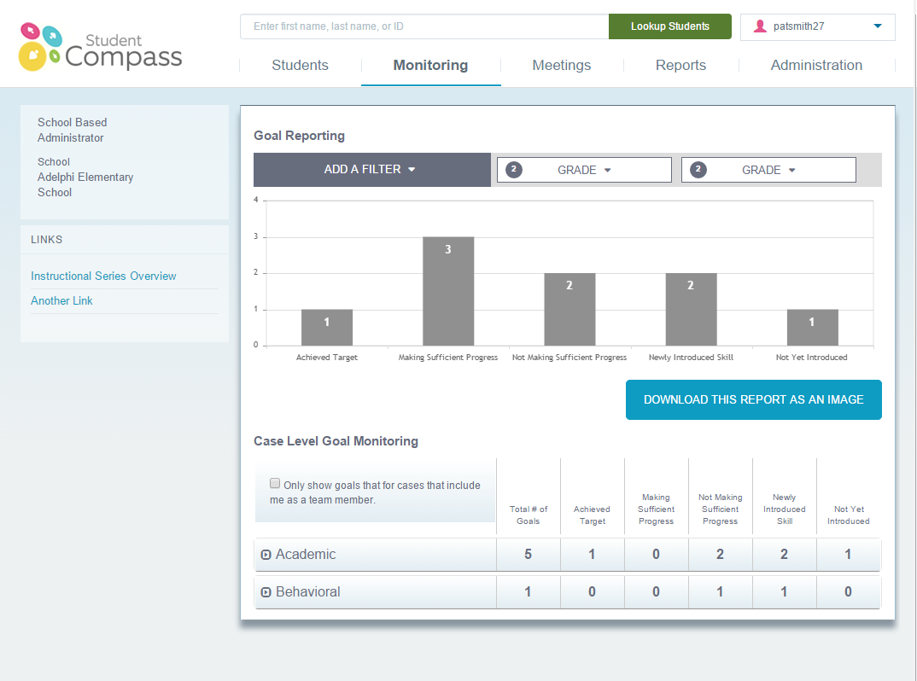 | 