Scale: 100,000 students and 10,000 users
Partner: Johns Hopkins University, The Center for Technology in Education
No.Inc partnered with Johns Hopkins University’s Center for Technology in Education to plan, design, and develop the Teacher Compass tool. The tool is used in the classroom to document teacher observations in real time. Multiple observations are scored using a rubric. Scores and notes are compiled into final evaluations for teachers. Professional development resources are then recommended to teachers based on the results of evaluations.

The Challenges
- Develop an offline solution due to Internet connectivity issues in various schools
- Accommodate various use cases by including extensive configuration of content, assessments, rubrics, professional development resources, and workflows

Our Approach
- Develop pilot and plan for extensive user testing
- Take a modular approach, including recommendations for the development of standalone professional development library and development of an offline solution
- Integrate configurable rubrics for various needs

The Results
- Acquired by Pearson Education

Teacher Observation Form
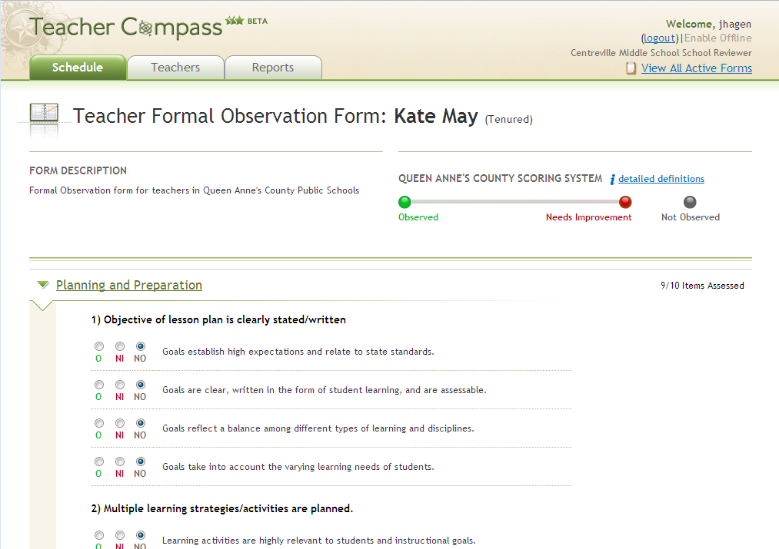
Reporting  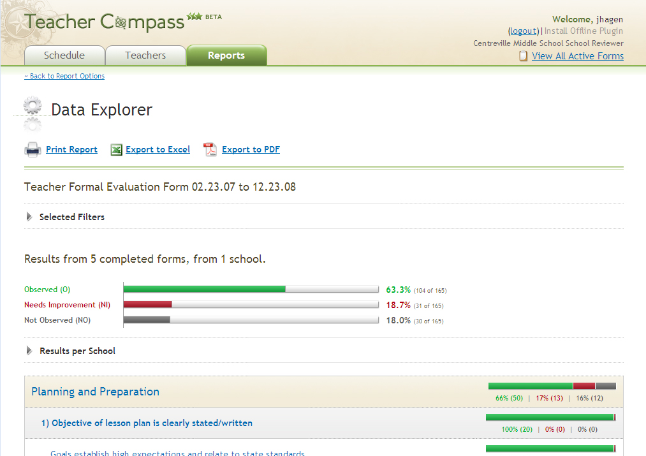 | 